**Logical Steps of SQL:**

1

a) Combining date and time fields into 1 field (Reason: for ease of calculating duration of session)

b) Creation of a PageUser_Key (Reason: Unique Identifier for users in specific pages, 2nd usage for this key is for LAG Partitioning in a later stage)

2. Converting the combined Datetimestamp field into seconds (Reason: Ease of calculating duration of user sessions)

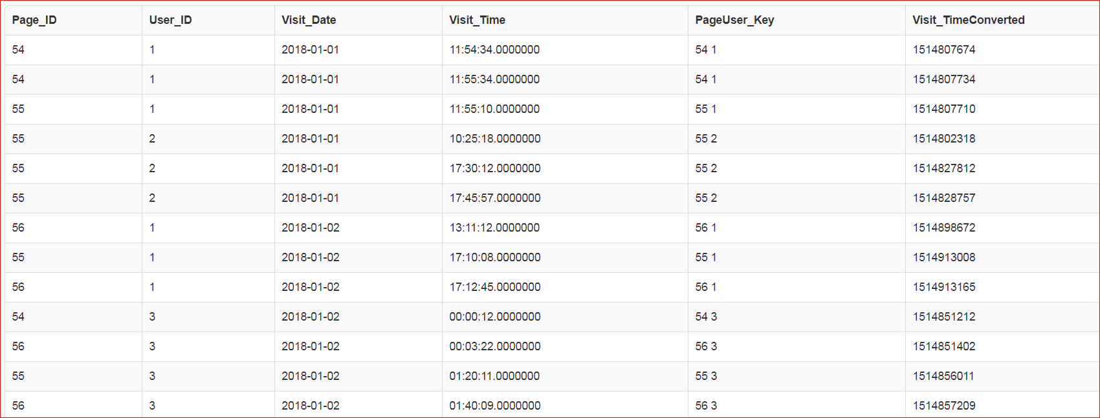

3. Added new field to show the start time (LastVisit_Time) for the previous session from the same user in the same page_id.

Reason: To be used as a building block to calculate the user session's duration in the same page_id

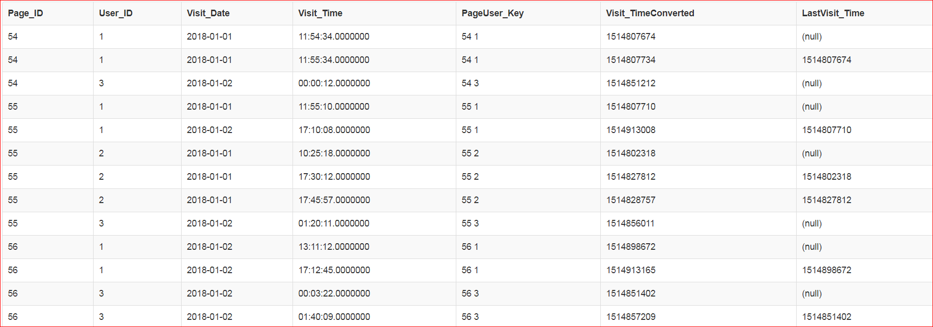

4. Using this new field, tagging '1' to the records which are > 10mins (600seconds) or NULL (1st session of the same user in the Page)

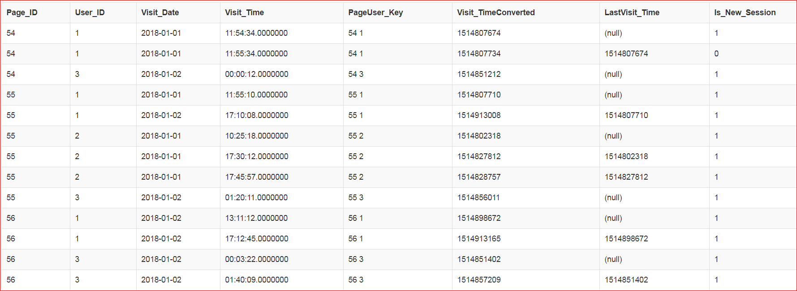

5. Finally, summing the total number of Sessions by Page and Visit Date.

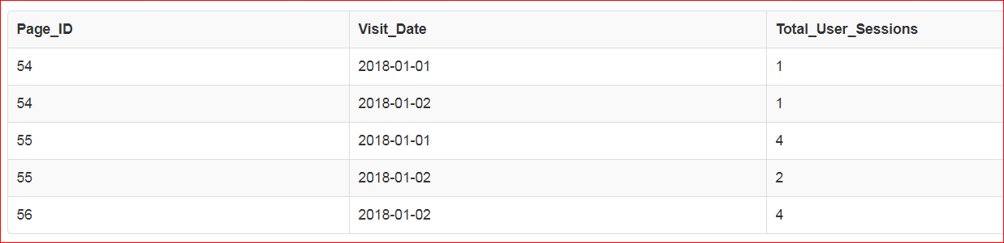

Final result is exactly the same as expected result.